**PROJECT REPORT SUBMISSION**

1. **INTRODUCTION**

**1.1 OVERVIEW:**

A CRM application for schools and colleges is a software tool designed to help educational institutional manage interactions and communication wih their students, parents, teachers, and other stackholders. The application is built to streamline administrative tasks, enhances communication, and improve overall sudent engagement and satisfication. Some of the key features of a CRM application for schools and colleges may include:

1. STUDENT DATABASE MANAGEMENT : The CRM system allows schools and colleges to manage student data, including academic performance, attendance, and contact information.
2. COMMUNICTION MANAGEMENT : The application can help institution manage communication with students, parens, and teachers, including email, sms, and other messaging platforms
3. ADMISSION MANAGEMENT : The CRM system can stream line admission process by managing application, scheduling interviews, and sending notification to applicants.
4. MARKTTING AND OUTREACH : The application can help schools and colleges promote their progammes and service by creating targeted marketing campaigns and tracking their effectiveness.
5. ANALYTICS AND REPORTING : The CRM sytem can provide detailed insights into student engagement, academic performance, and other key metrics, allowing instituions to make data-driven decisions.

Overall, a CRM application for schools and colleges can help institutions build stronger relationship with their students, improve communication, and enhance the overall educational experience.

**2.PROBLEM DEFINITION AND DESIGN THINKING**

2.1 EMPATHY MAP

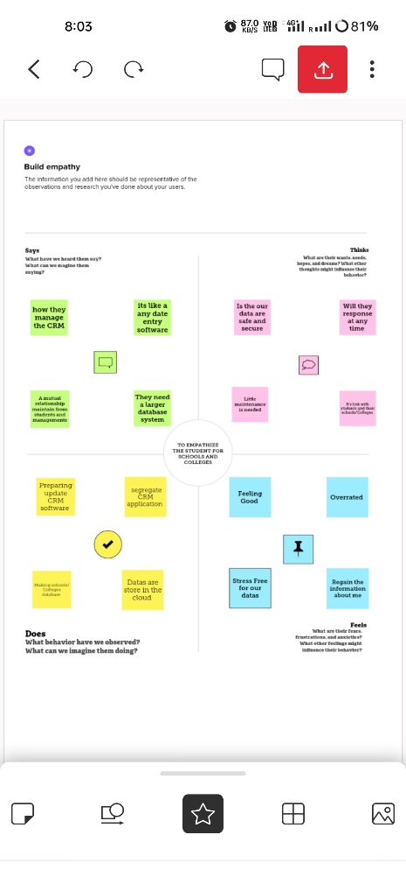

For clear visit use this link <https://app.mural.co/t/acrmapplicationforschoolsand6925/m/acrmapplicationforschoolsand6925/1679068814118/dc07f690caaf0d84612ed8c26ab000ca996ccc7b?sender=u43cbfaa26513a68e51a98300>

2.2 IDEATION AND BRAINSTORMING MAP 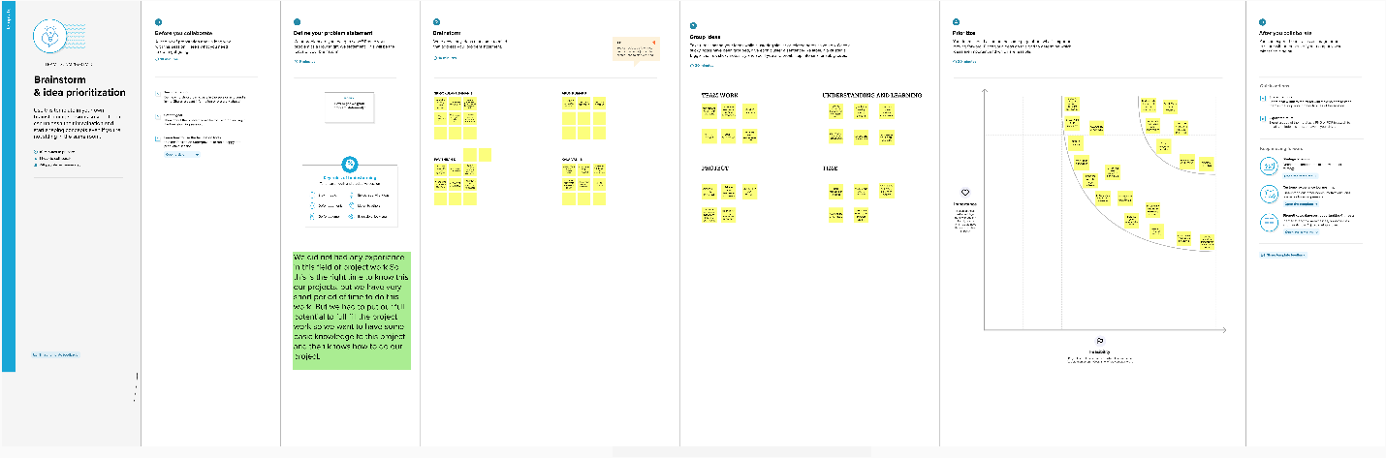

For clear visit use this link <https://app.mural.co/t/acrmapplicationforschoolsand6925/m/acrmapplicationforschoolsand6925/1679146283688/5e80df93810e80903fb0d6473871f9895a03b19f?sender=u43cbfaa26513a68e51a98300>

**3.RESULT**

3.1 DATA MODEL :

|  |  |
| --- | --- |
| **OBJECT** | **FIELDS IN TH OBJECT** |
| **SCHOOL** | |  |  | | --- | --- | | **FIELD LABEL** | **DATA TYPE** | | SCHOOL NAME | TEXT (80) | | ADDRESS | TEXT (225) | | DISTRICT | TEXT AREA (255) | | STATE | TEXT AREA (255) | | NUMBER OF STUDENT | ROLL-UP SUMMARY (COUNT STUDENT) | | HIGHEST MARK | ROLL-UP SUMMARY (MAX SUDENT) | | PHONE NUMBER | PHONE | | SCHOOL WEBSITES | TEXT (255) | |
| **OBJECT** | **FIELDS IN TH OBJECT** |
| STUDENT | |  |  | | --- | --- | | **FIELD LABEL** | **DATA TYPE** | | CLASS | NUMBER (18,0) | | MARKS | NUMBER (18,0) | | PHONE NUMBER | PHONE | | RESULTS | PICKLIST | | SCHOOLS | MASTER-DETTAIL (SCHOOL) | | NAME | TEXT (80) | |
| PARENT | |  |  | | --- | --- | | **FIELD LABEL** | **DATA TYPE** | | NAME | TEXT (80) | | ADDRESS | TEXT AREA (255) | | PARENT NUMBER | PHONE | |

**3.2 ACTIVIY AND SCRENSHOT**

ATTACH SCREENSHOTS OF OUR PROJECT ACTTIVITY ALONG WITH THE DESCRIPTION.

**The prototype of the CRM application for institutional management is developed using salesforce with help of project manual guide and tested with user data. The complete project activities are attached below in image format.**

**CREATION OF DEVELOPER ACCOUNT**

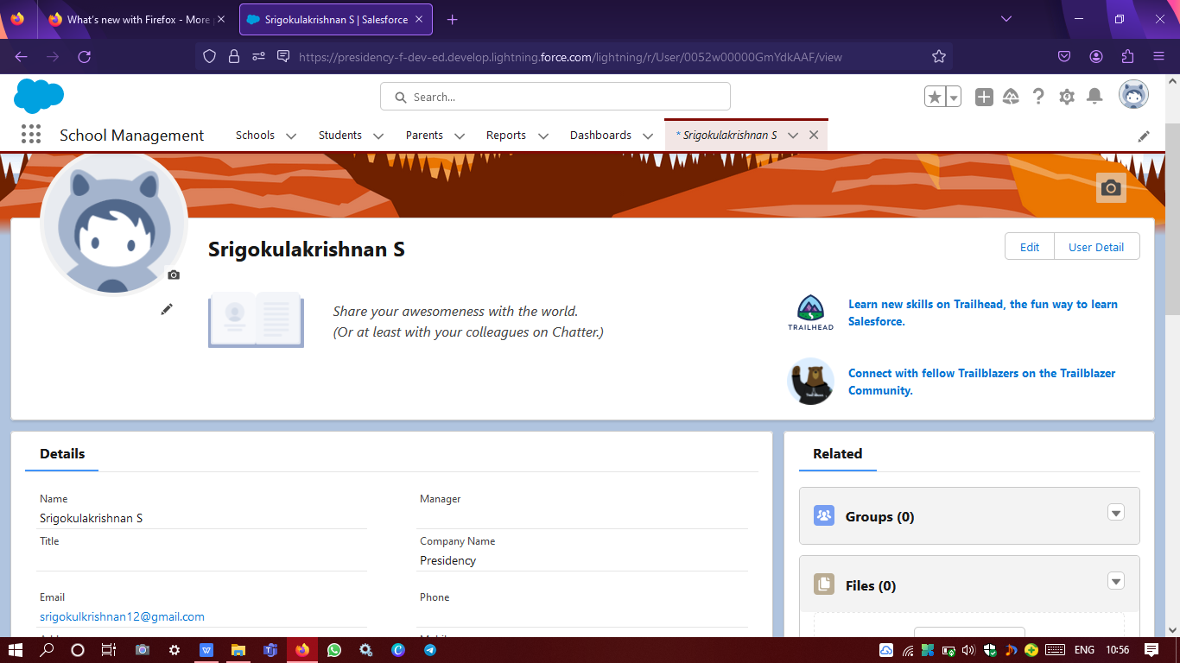

**For developing the app we need to create one developer account**

**Creation of objects**

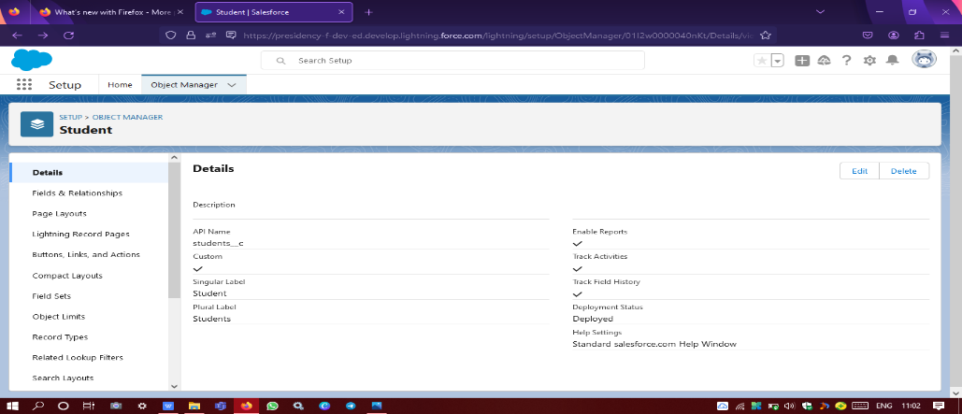

**Student object is created**

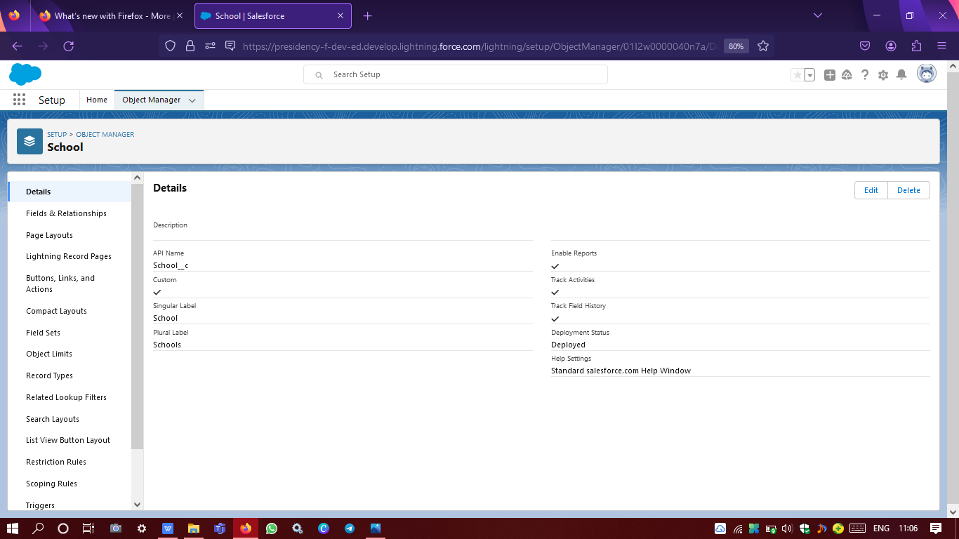

**School object is created**

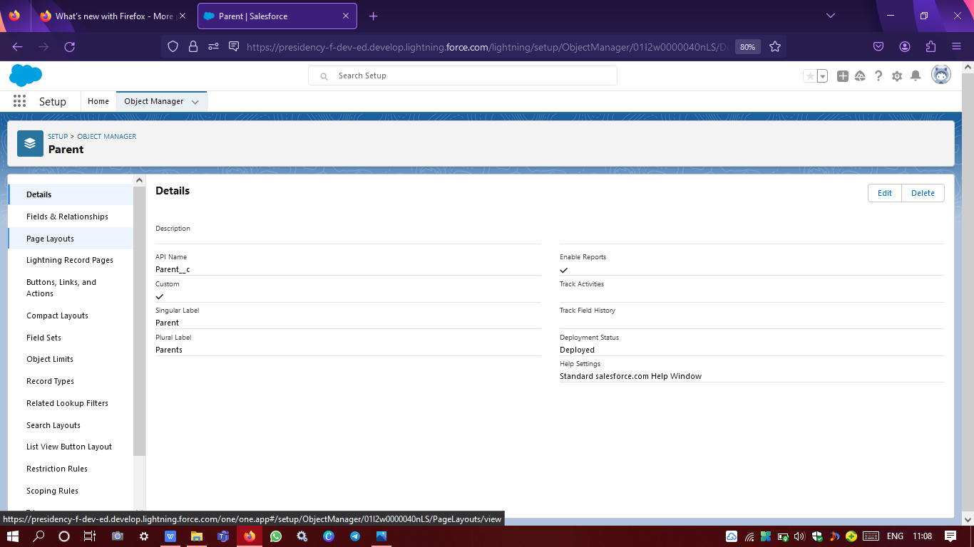

**Parent object is created**

**CREATION OF FIELDS & RELATIONSHIP**

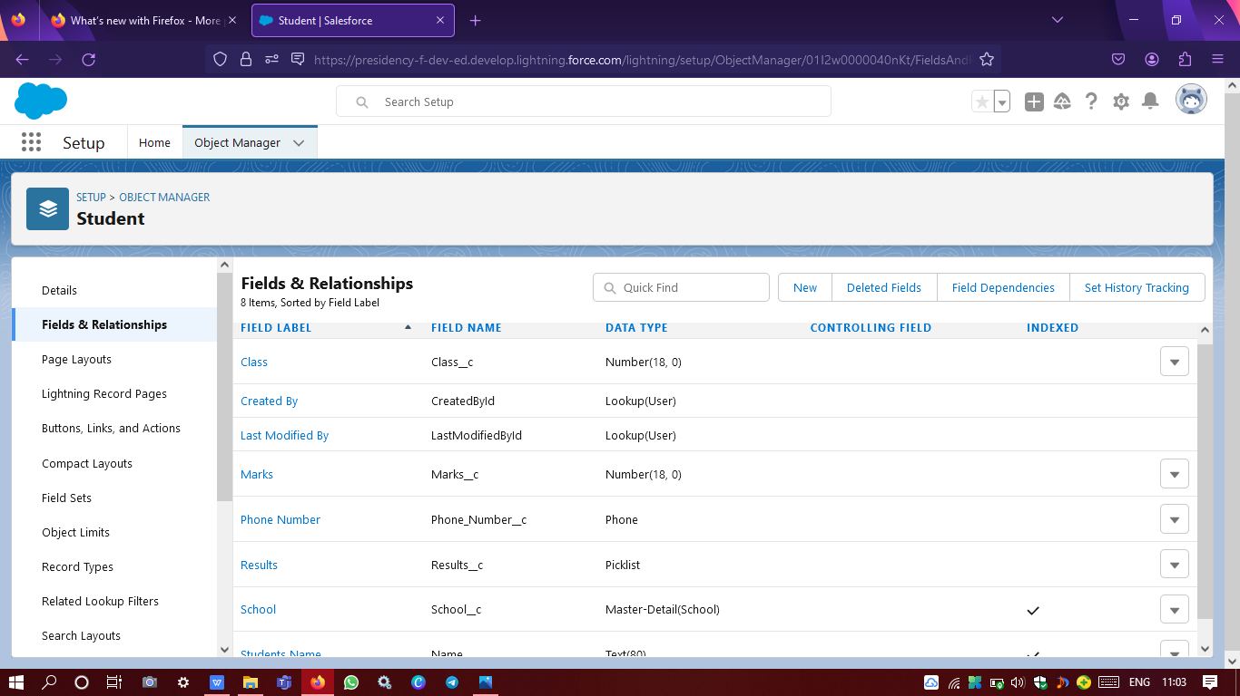

**Student field and relationship is created**

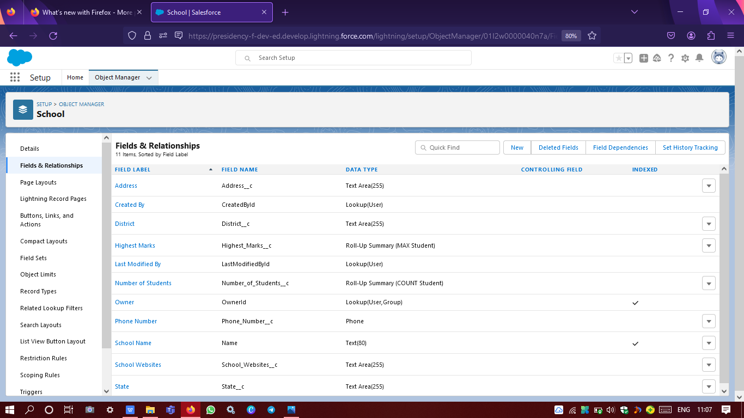

**School field and relationship is created**

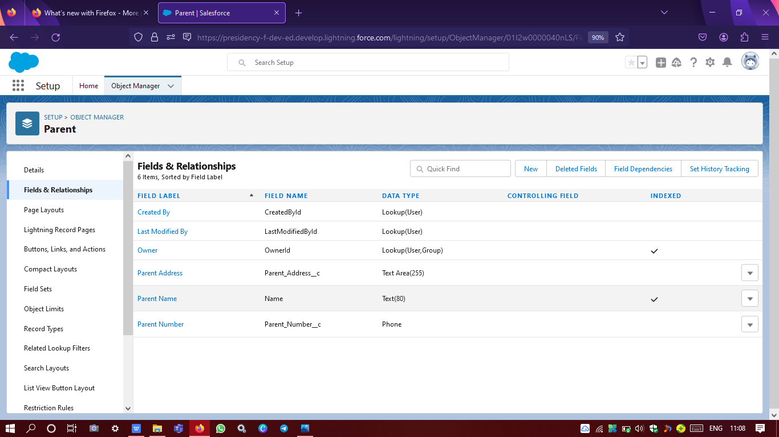

**Parent field and relationship is created**

**CRATION OF SCHOOL MANAGEMENT APP**

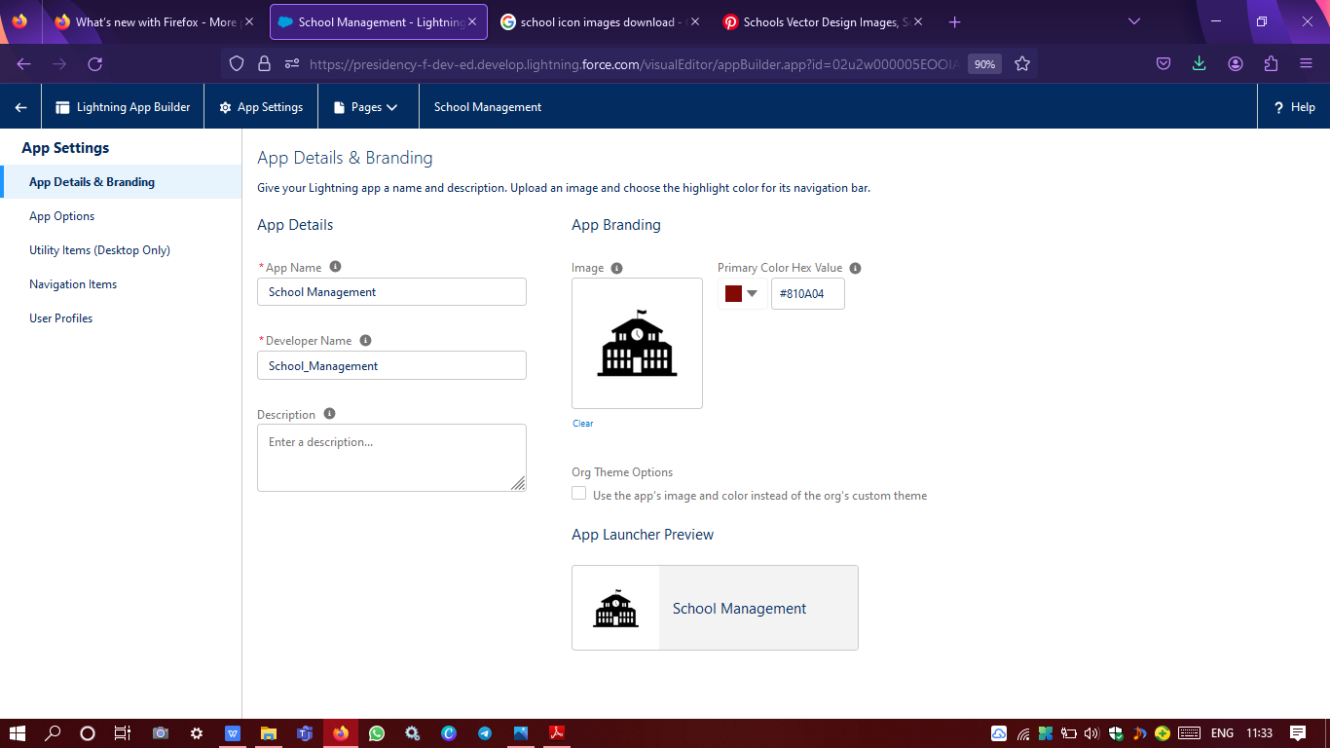

**The image is created for school management app**

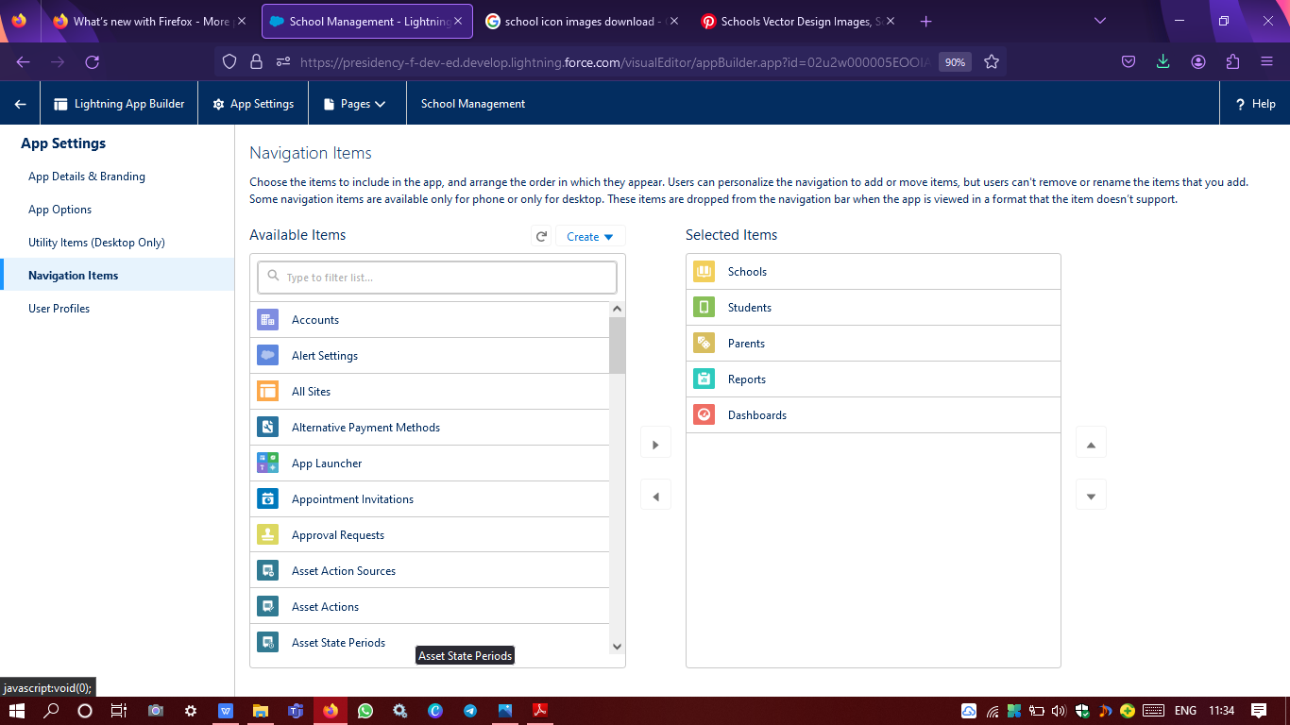

**Selecting navigation items in app settings**

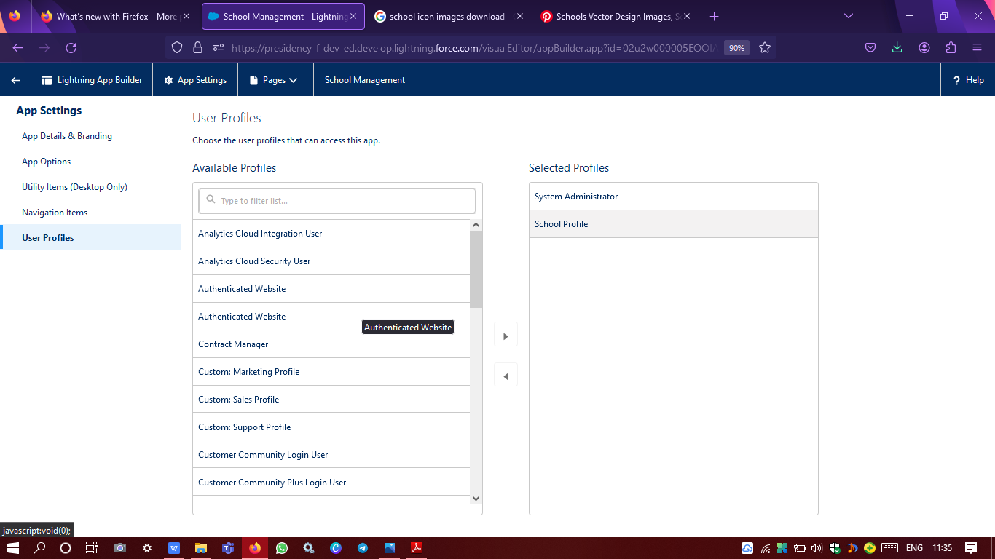

**User profile selection in app settings**

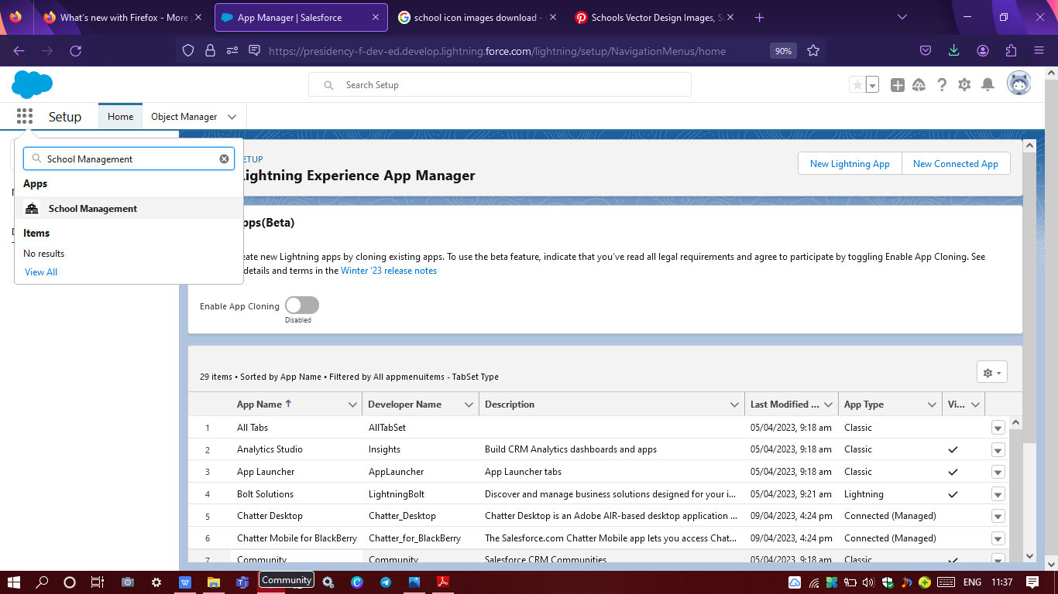

**Created app available in app launcher**

**PROFILE CREATION**

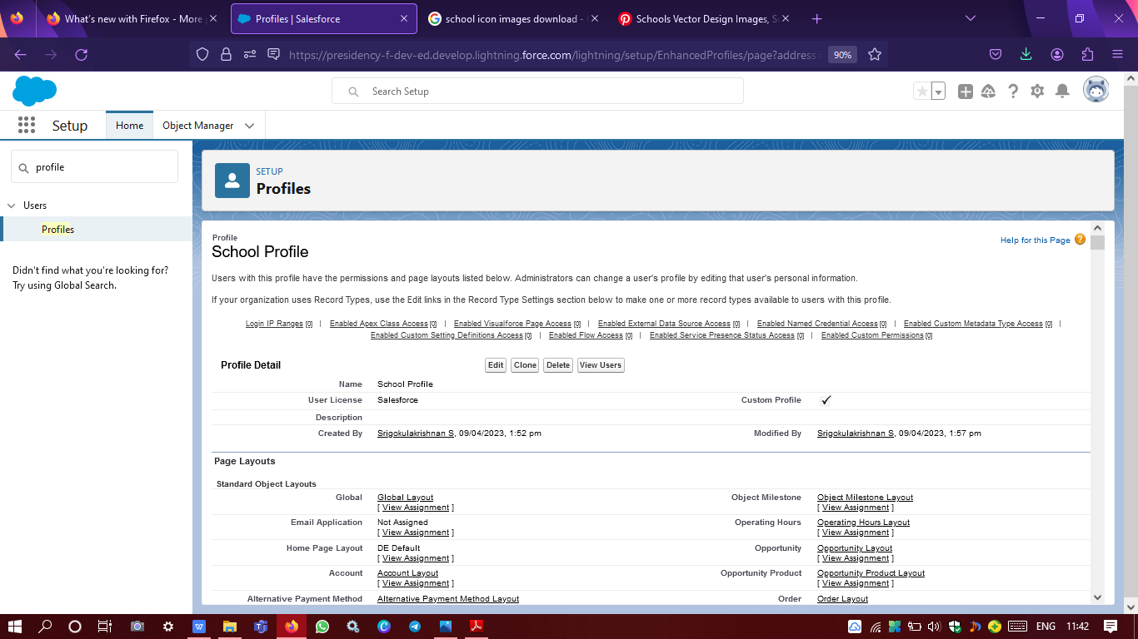

**Created school profile assigned to parent profile**

**USERS CREATION**

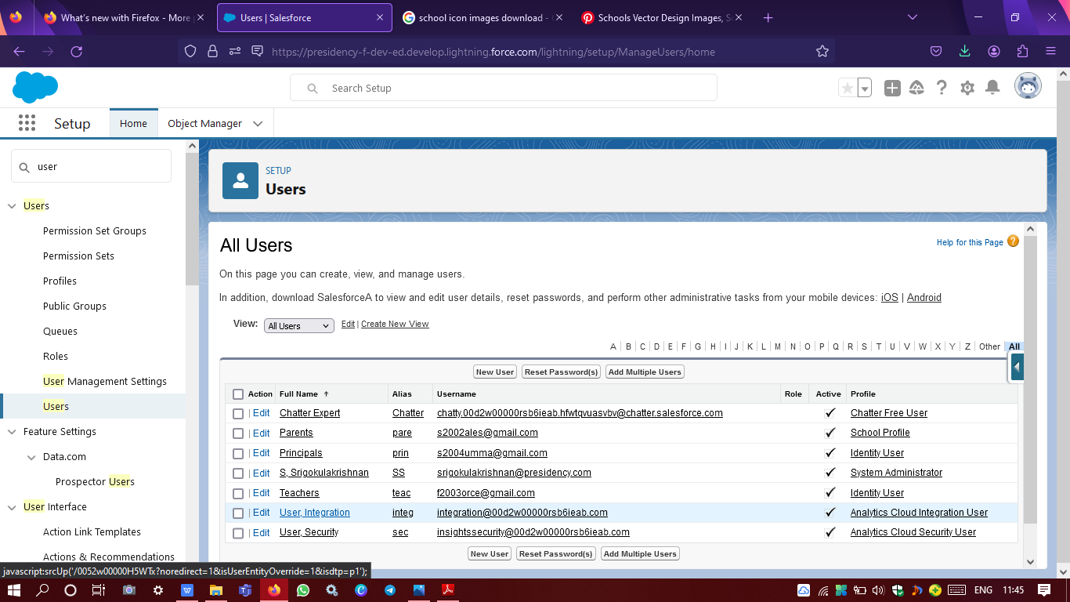

**Principals, Teachers & Parents multiple user profile creation**

**PERMISSION SET**

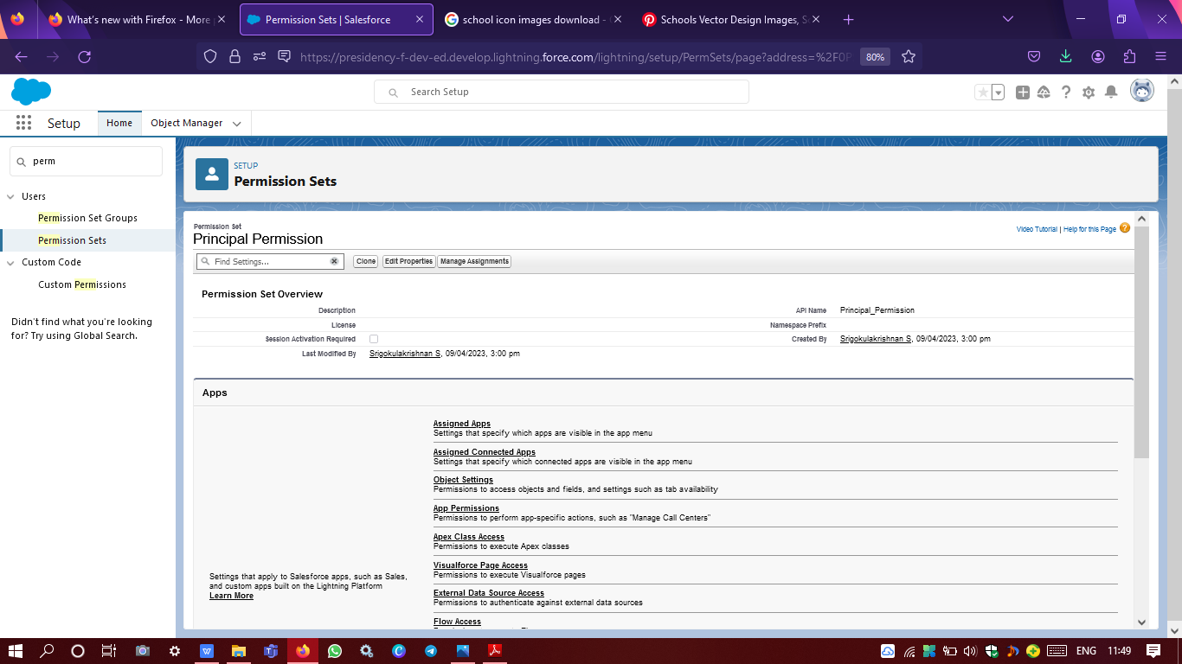

**Created principal permission set**

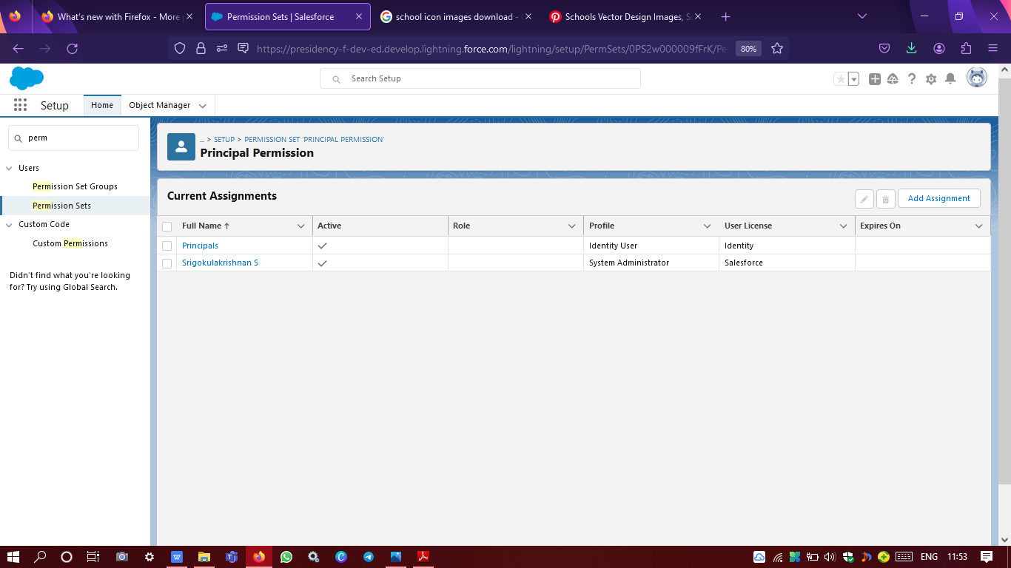

**Principal permission set assigned to principals profile**

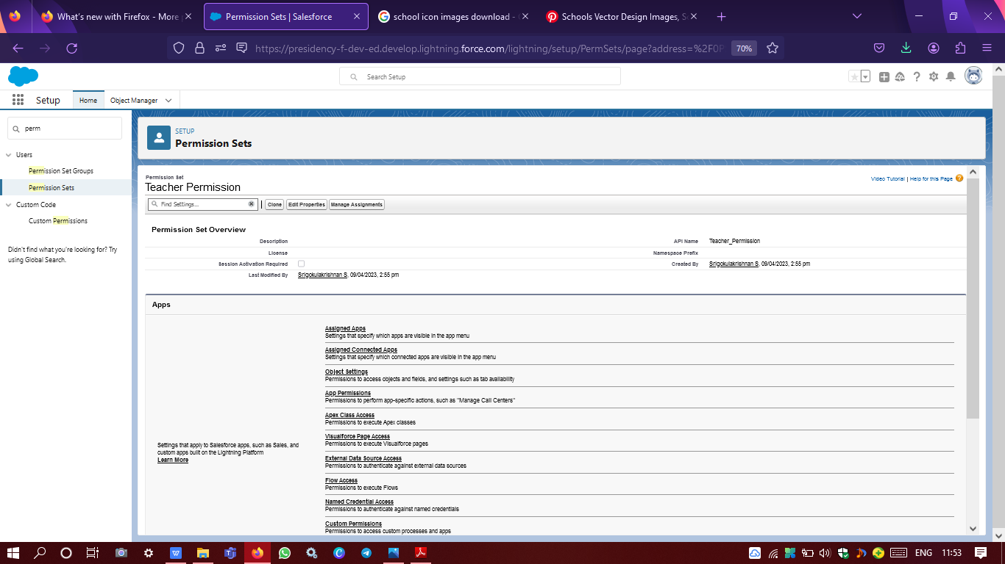

**Created teacher permission set**

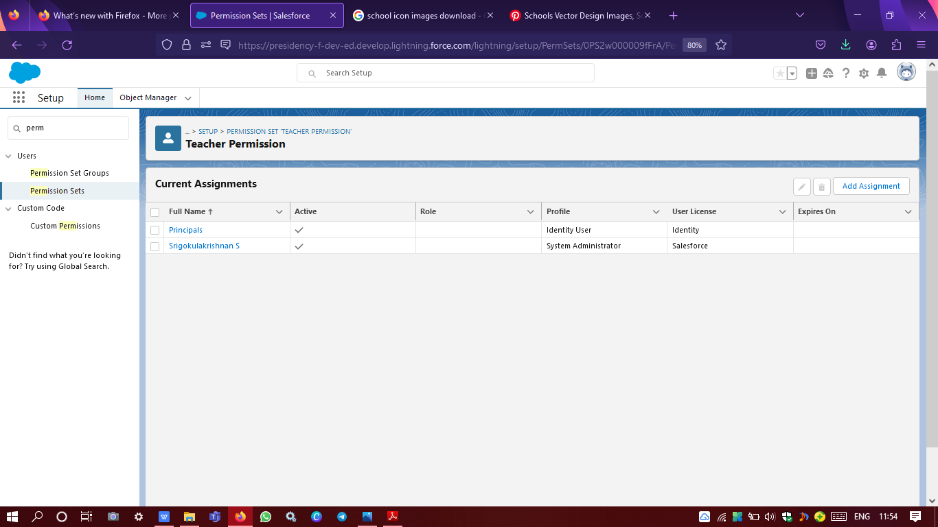

**Teacher permission set assigned to teachers profile**

**RESULTS**

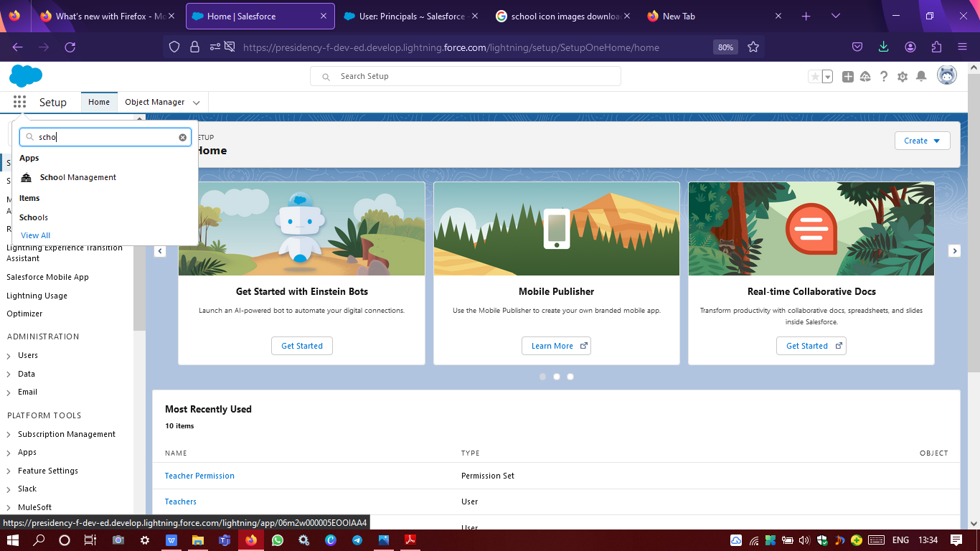

**School management application icon available in app launcher**

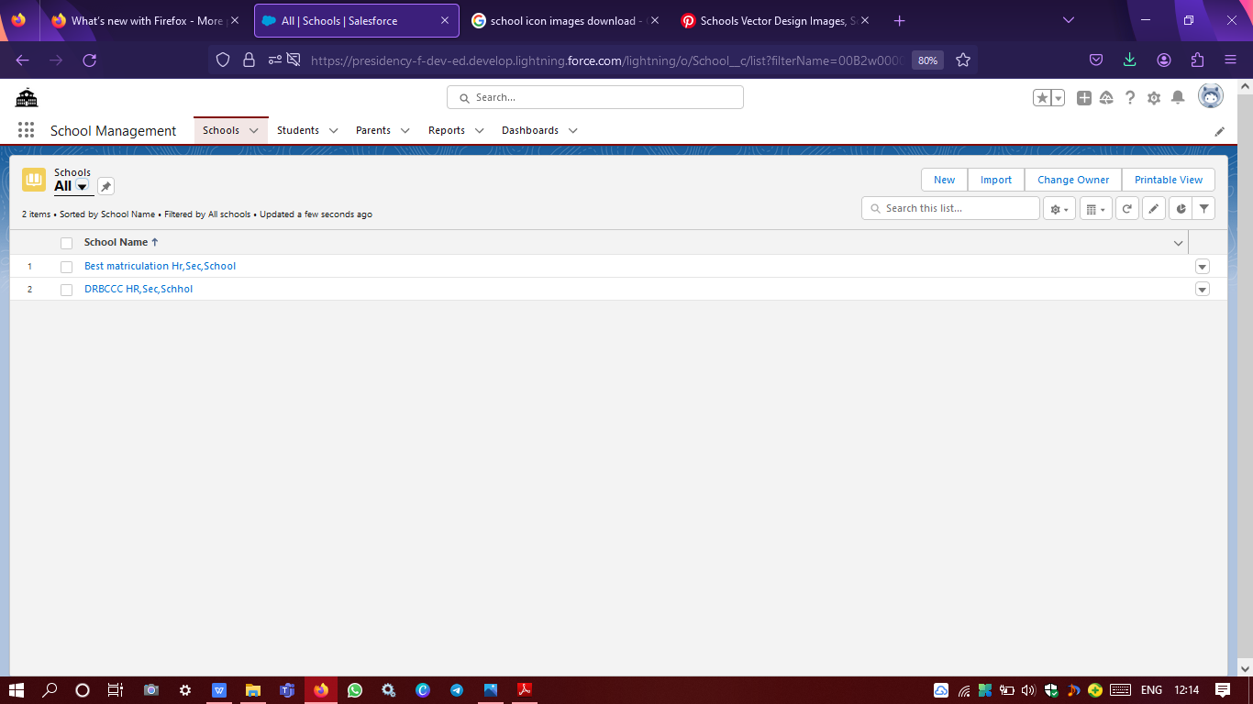

**Schools tab in CMR application**

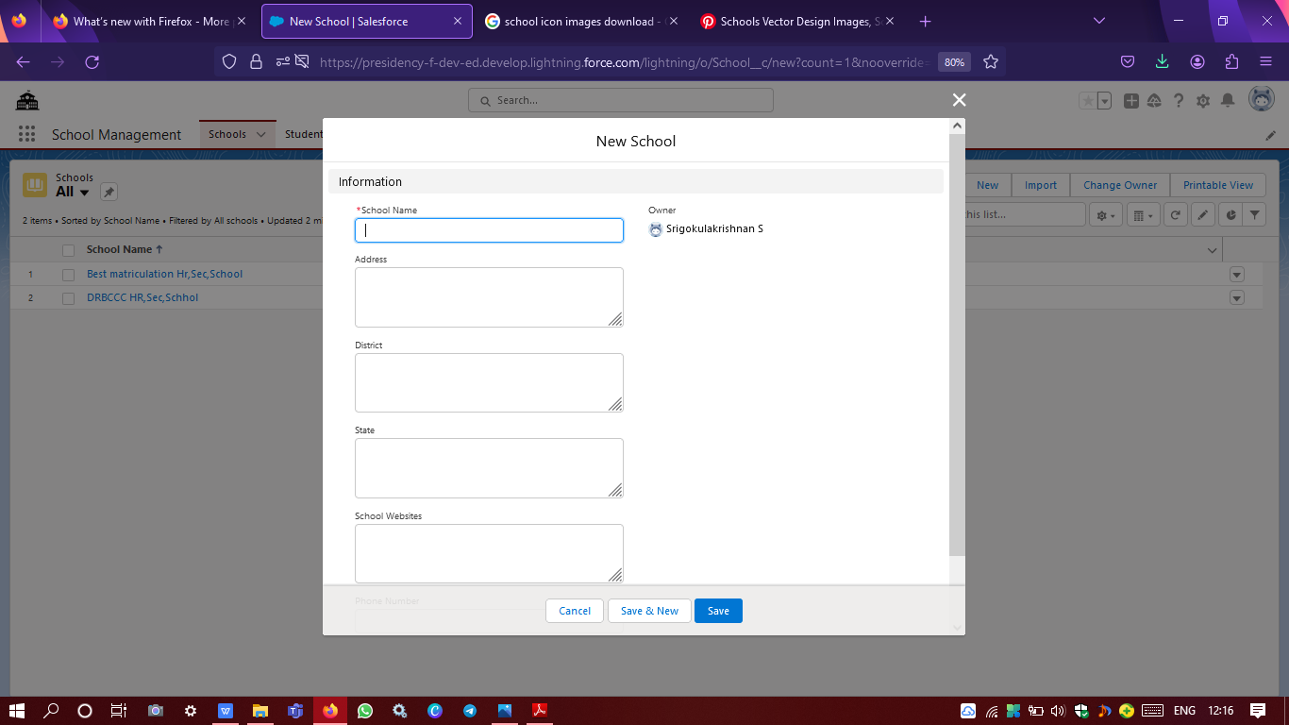

**School object with fields**

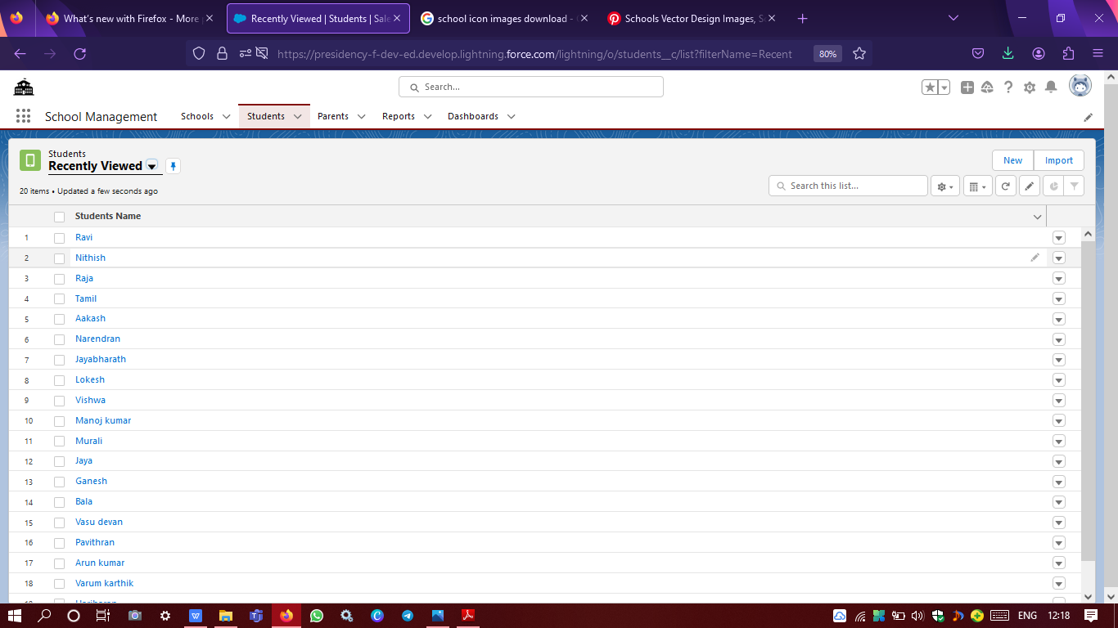

**Students tab in CMR application**

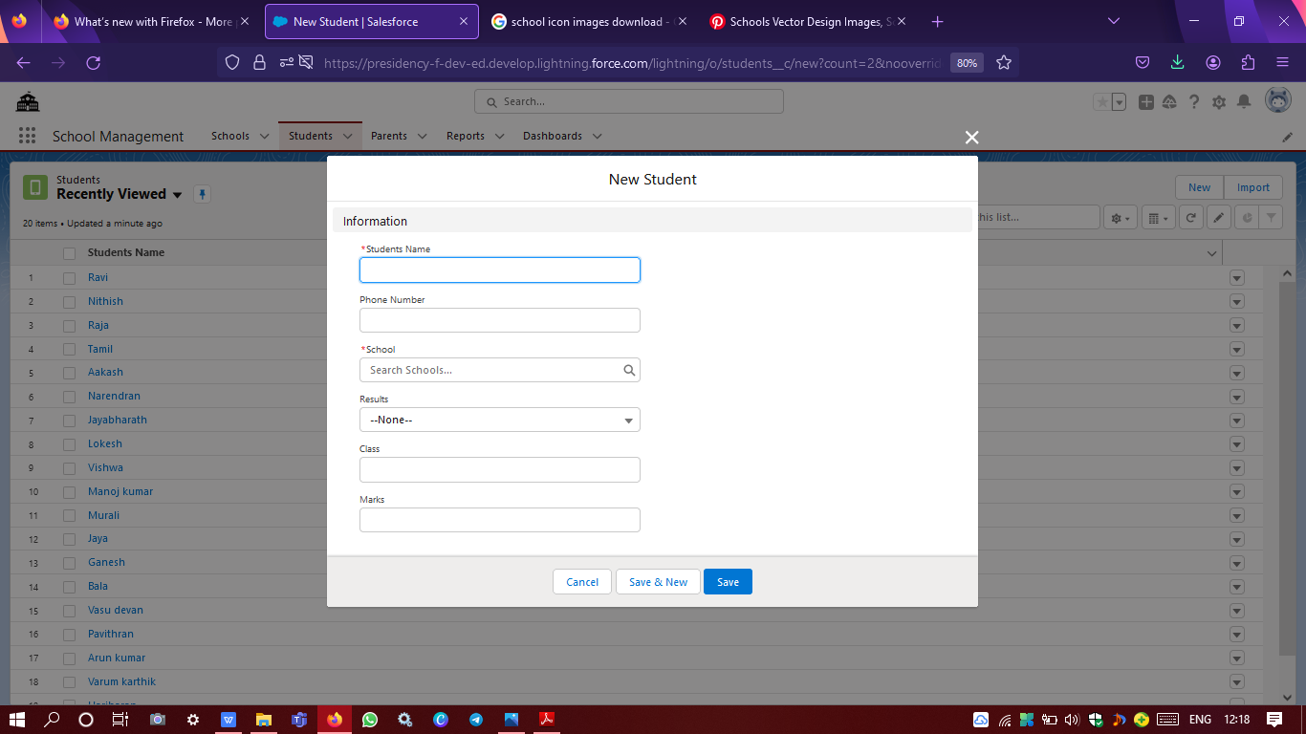

**Student object with fields**

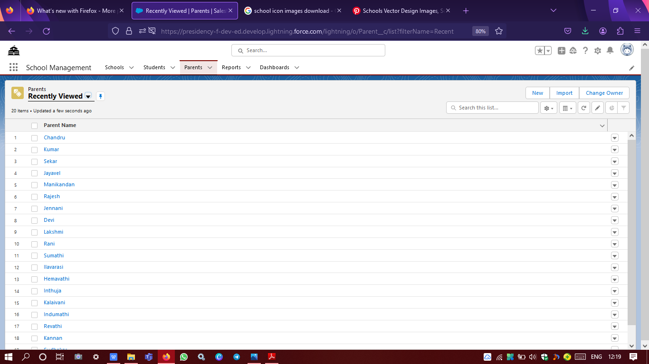

**Parents tab in CMR application**

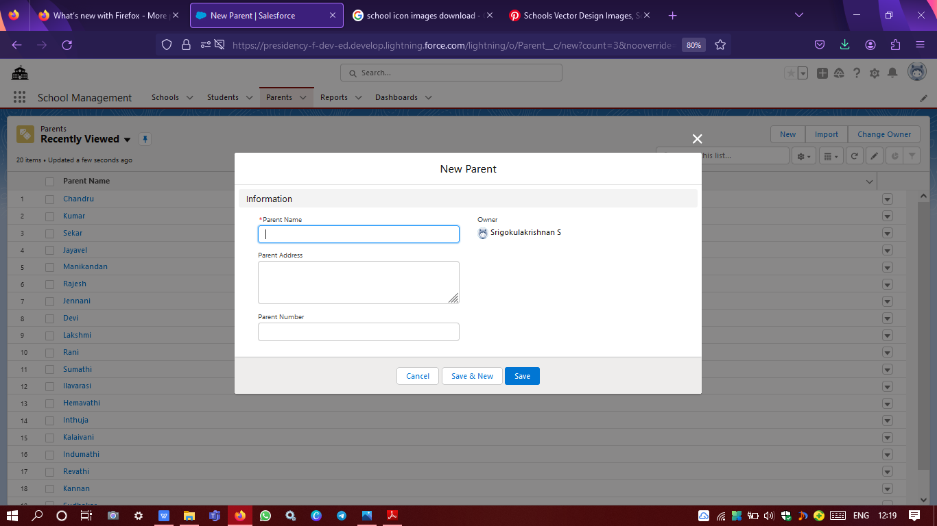

**Parent object with fields**

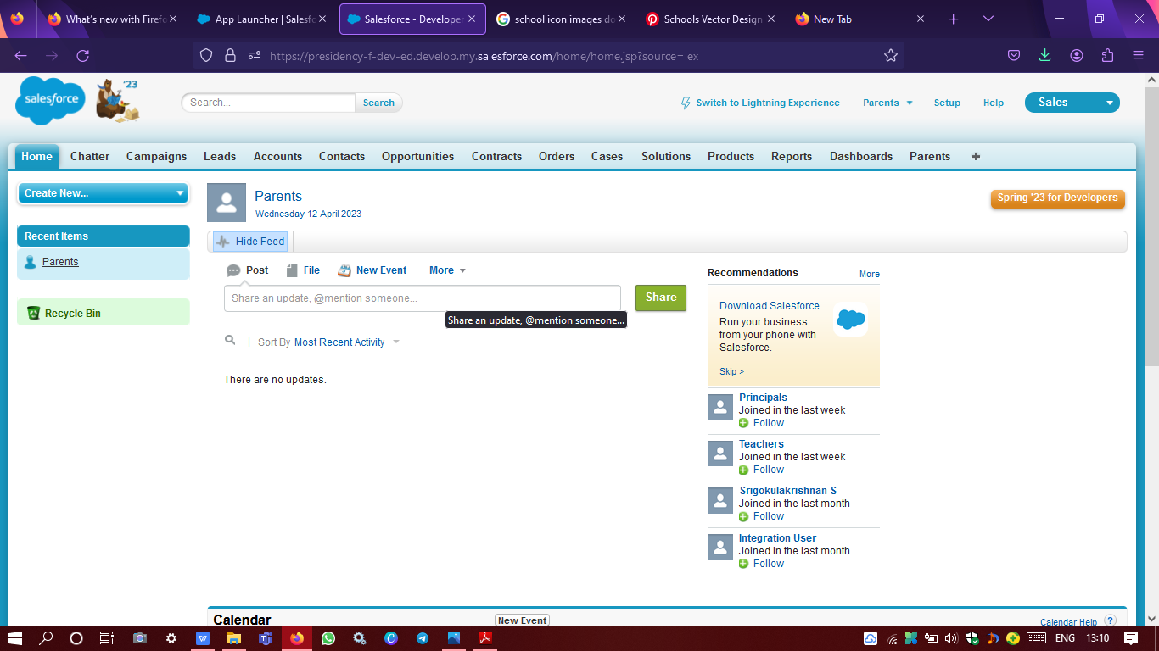

**Parents user profile login**

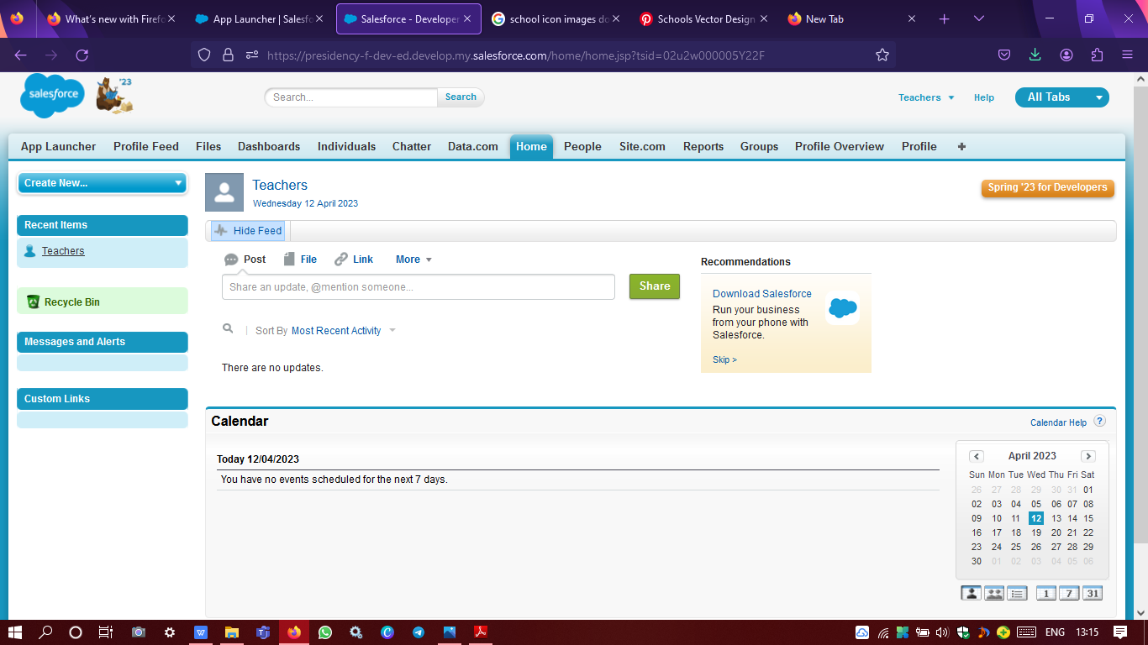

**Teachers user profile login**

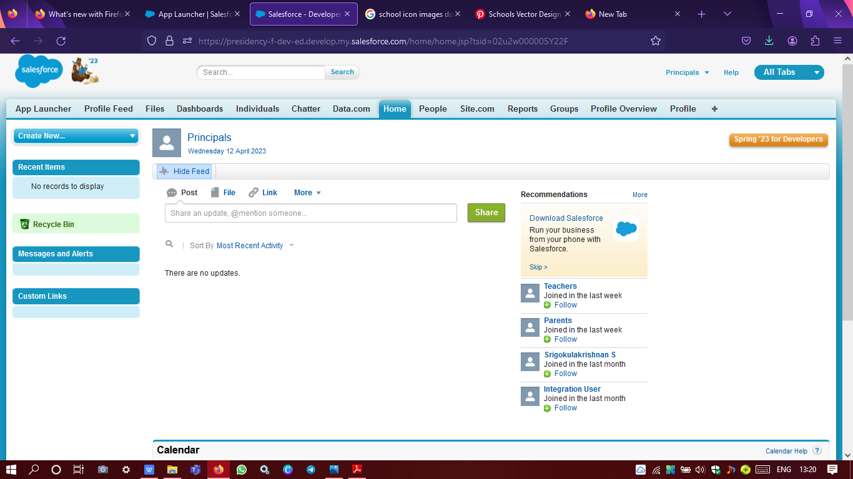

**Principals user profile login**

**REPORTS**

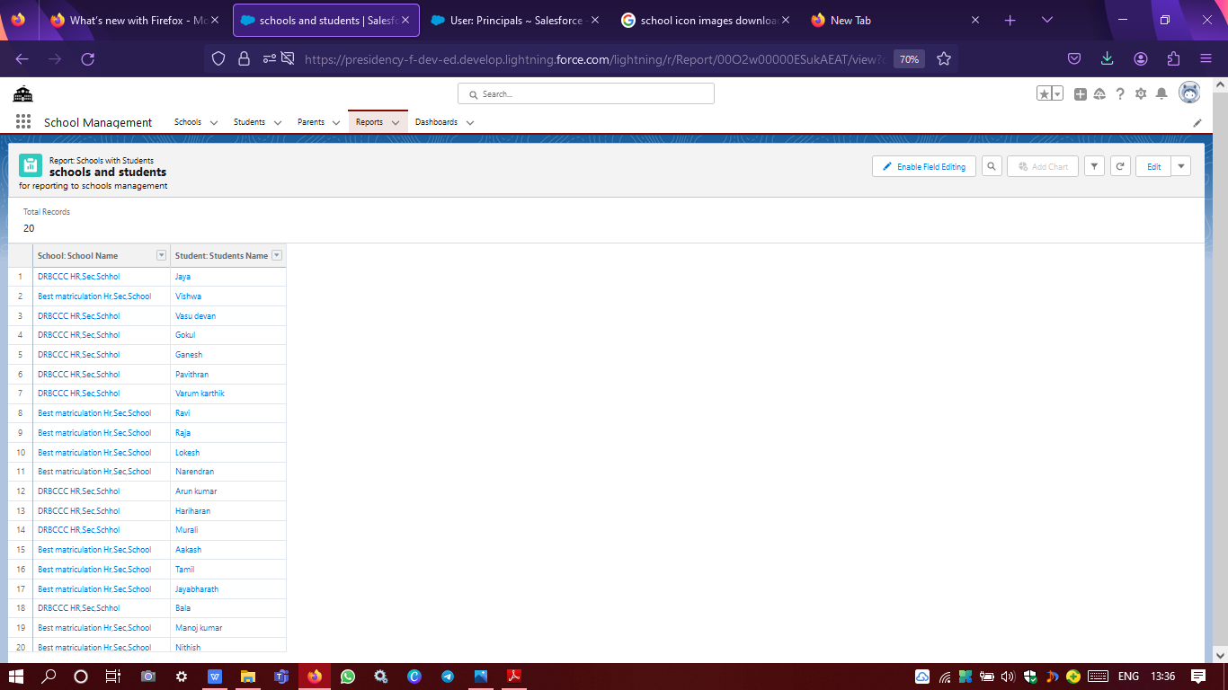

**Schools with students and parents customizable report from the fake user data**

**given for testing**

**4. TRAILHEAD PROFILE PUBLIC URL**

Team ID: NM2023TMID06665

**TEAMLEADER ID:** [**https://trailblazer.me/id/srigokul06**](https://trailblazer.me/id/srigokul06)

**Teammember 1 ID:** [**http://trailblazer.me/id/arun1703**](http://trailblazer.me/id/arun1703)

**Team member 2 ID:** [**http://trailblazer.me/id/pavithran16**](http://trailblazer.me/id/pavithran16)

**Team member 3 ID:** [**http://trailblazer.me/id/kkalaivani**](http://trailblazer.me/id/kkalaivani)

**5.ADVANTAGES AND DISADVANTAGE**

**Advantages:**

**Improved communication : The CRM application can help schools, colleges to better commnicattionwith students, parents and other stakeholders by providing a centralized platform for all communication channels.**

**Enchances student experience : The CRM application can provide a personalized experience for students by tailoring information and service to their specific needs, preferences, and interests.**

**BETTER COLLABORATION: The CRM application can facilitate collaboration between staff members, departments, and even with external stakeholders such as alumini and industry partners.**

**DISADVANTAGES**

**COST : Implementing a CRM application can be expensive and schools and colleges may need to allocate significant resources to cover the upfront and ongoing costs of implementation, maintenance, and support.**

**RESISTANCE TO CHANGE : Staff members may be resistant to be adoption of a new system particularly if they are not familiar with the technology or have established routiues and processes.**

**TECHNICAL ISSUES: Technical issues such as system failures , breaches can disrupt the functioning of the CRM application and affect its usefulness**

**APPLICATIONS**

**AREAS ARE TO BE USED**

**STUDENT ADMISSION : The application can be used to manage the student admission process,including application tracking, document management, and communication with application.**

**STUDEN ENGAGEMENT: The application can be used to track student attendance, generate reports and notify parent and teachers of absenteeism.**

**ACADEMIC PROGRESS TRACKING : The application can be used to track student academic progress, including grades, assignments, and exams.**

**ALUMINI RELATION : The application can be used to manage alumini relation, including communication, fundraising and events.**

**RESOURCES MANEGEMENT: The application can be used to manage school resources, such as classroom, equipment, and facilities**

**COMMUNICATION MANAGEMENT : The application can be used to manage communication between sudents,staff and parents, through channels such as emails, sms, and social media.**

**CONCLUSION**

**The proposed CRM application for schools and colleges can be a valuable tool for improving customer/student relationship management, increasing efficiency, personalizing the student experiences, managing data more effectively and improving communication. However, there are also some potential challenges such as cost, data, privacy, and security the learning curve, resistance to change, and maintenance.**

**Overall the CRM application for schools and colleges has the potential to transform the way educational institutions interaction with students and manage their operation, leading to higher satisification rates, improved academics outcomes, and better resources allocation.**

**FUTURE SCOPE**

**INTEGRATION WITH OTHER SYSEM: To create a more holistic view of the sudent experience and improve data management.**

**PREDICTIVE ANALYTICS : The application could use to predictive analytics to identify pattern and trends in students behaviour, such as attendance, academics progress.**

**SOCIAL MEDIA INTEGRATION: The application could integrates with social media platforms to provide a more seamless and convient communication channels for students, staffs, and parents.**

**PERSONALISED DASHBOARD : The application could offer personalized dashboard for students, staffs, and parents, providing a tailored view of relevant data and insighs.**